HapTex:A Database of Fabric Textures for Surface Tactile Display

【Main Content】：

This article presents a database of tactile textures, which is defined by the friction during the interaction between the bare hand and the real fabric. The application of the database is illustrated by a haptic texture modeling and rendering example that allows users to feel a virtual haptic texture on an electrostatic haptic display.

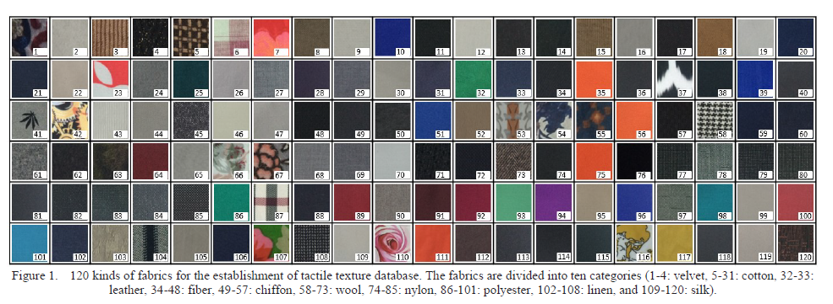

【Data Collection】:

1. **Fabric Texture Samples**
2. **Measurement Apparatus**
3. **Recording Procedures**
4. **Recorded Data**

【Electrostatic Tactile Display】:

For creating haptic textures of fabrics, an electrostatic tactile display was utilized, as shown in Figure 6. The haptic interface was composed of following three layers. The top layer is an optical positioning sensor (GSC0320, TMDTOUCH, China) with the accuracy of 0.01 mm for detecting the displacement of finger movement. The middle layer is a haptic capacitive touch screen panel (SCT3250EX, 3M Touch Systems Inc., US), which can generate the electrostatic tactile stimulation. The bottom layer is an LCD screen (Surface Pro 3, Microsoft, US) for displaying visually information of material. The previous works have indicated that the electrostatic tactile display device can render haptic textures of images and detailed shapes on the surface by modulating input voltage signals [22], [33], [34].

